MAKHAN LAL KUSHWAHA

Contact: +91-9506582365
E-Mail: makhanlalshiats@gmail.com
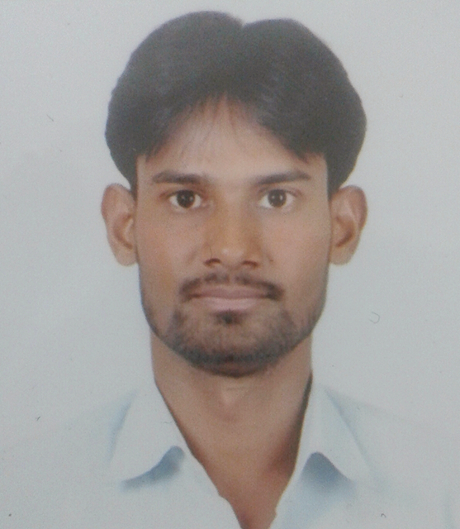
Intend to build a career with a leading organization which will help me utilize my creativity to the fullest and realize my potential to contribute to the organization’s success and gain an in-depth knowledge in my intended area of expertise.
Preferred Location: Anywhere in India

Educational Qualification

Passed B-tech Agriculture Engineering
Secured 75% marks
XII
U.P. Board in 2012. Secured 64% marks.

X
U.P. Board in 2005. Secured 46% marks.

Training & Experience

- One month summer training on “Manufacturing and Testing of HMT LIMITED PINJORE PANCHKULA (HARAYANA)
- Four weak summer training on “Computer Aided Design (Creo Elements/Pro)” from June02- 29, 2014 at MiTsU..
- Two days national Conference on “Water Demand, Sustainability and Future” from may o3-04 at MNNIT, Allahabad (U.P.).
- One day national workshop on “Professional Communication” on 29th January 2013 at SHIATS, Allahabad.
- One day Nikon School workshop on A beginner& “Advances photography on 21november 2014 at
SHIATS, Allahabad.
- Two days workshop on solar water pumping system’’ from National institute of solar energy GURUGRAM HARAYANA.
- Certificate of course on computer concepts from NIELIT (formerly DOEACC society).
- Currently working Agricultural Engineering Apprenticeship training from GOVT.N.R.F.M.T.&T.I HISAR HARAYANA from 27/06/2017 to Till date.
Personal Vitae
Father’s name: Sri Janki prasad
Date of Birth:, 02,march,1989
Gender: Male
Postal Address:
Sekhan fatak
Post- Charkhari
District -Mahoba 210421(UTTAR .PRADESH)
Linguistic Abilities: English / Hindi
Hobbies: Net Surfing ,Interacting With new people, Travelling & listening music
Strength: Strong logical and analytical skills
- Capability to work in a stressful environment and under pressure.
- Ability to handle any kind of conditions self - confidence
- Skills
- Ability of understand the use of product
- Aware of technical aspects of engineering
- .Excellent project management skills
- Strong leadership skills
- Experience in maintaining and repairing mechanical and electrical system including system test.
- Ability to travel to different places as required.

Responsibilities-
- Understand the market trends
- Maintain records of important clients.
- Participate to develop and introduce new product to the market .
- Conduct different program to receive feedback regarding product launch.
- To coordinate between product engineer and sale department for product issues.
- Prepared and conducted technical sale briefings for customers and company representatives .
At last sir I want to say that if you give me job then I will give me hundred percent.
Declaration:

I hereby declare that the above mentioned particulars are true to the best of my knowledge and belief.
.
- That`s all sir It`s all about me thanks for reading& given the time.

Date: 29/03/2018

